# Lecture 0: Intro

Assessment:

* Online Quizzes (25%)
* Essay (25%)
* Examination (50%)

Middle English – The name given to the varieties of the English language in use between c.1150 – c.1500

* Handwritten
  + Age of the Quill Pen, Goose-Feather Pen

# Lecture 1: Chaucer’s Life

Address / contact details:

* Born in Upper Thames Street, London

Date of Birth: 1340-45

* Son of a wine merchant
* Middle class

Marital Status:

* Married to Philippa de Roet (1366)
  + 2 sons: Thomas and Lewis

Education:

* ???

Career / employment record:

* Poet/author – non-existent idea
* 1356: page for the earl and countess of Ulster
* Customs controller in the port of London
* 1389: Clerk of the King’s Works
  + risky – robbed multiple times
* 1399: retires from royal service

Salary and bonuses:

* A pitcher of wine a day for his life (no evidence)
* Annual payment
* Rent-free house in London, Aldgate

Languages:

* London dialect of English
* French
* Italian
* Latin

Foreign travel experience:

* Florence, Italy (1373)

Criminal Convictions:

* ‘Raptus’ (rape/abduction) of Cecily Chaumpaigne
* Beating a friar in Fleet Street

Hobbies and interests:

* Poetry

References:

Timeline:

* 1066 Norman Conquest and a new French-speaking ruling class in England
* 1337 Hundred Year War with France begins (ends 1453)
* 1340? Chaucer born
* 1346 English victory at Crecy in France
* 1348-50 The Black Death
* 1356 English victory at Poitiers in France
* 1359-60 Chaucer serves in the war in France
* 1361-62 Recurrence of the Black Death
* 1362 English becomes the official language of the courts and parliaments in England
* 1381 The Peasants’ Revolt
* 1382 The Bible is translated into English (‘Wycliffite Bible’ – banned by the authorities)
* 1387-92 Chaucer begins *The Canterbury Tales*
* 1400 Chaucer dies

Why write in English?

* English on the rise
  + - [timeline reasons]
* Visit to Italy inspired to write in vernacular, own language
* The living language
  + Nuances
  + Speakers with different voices

Overall:

* a man of the world
* educated but not bookish
* the son of urban traders
* came into contact with a wide spectrum of medieval society
* life and times are reflected in his language and literary creations
* uses the living language of English

# Lecture 2: Spelling, Sounds, Alisoun

## Spelling

No standard spelling

* **Variance can reflect regional pronunciation**

Example: [f] and [v]

* Northern dialects: fox, fixen
* Southern dialects: vox, vixen
* PDE (present day English): fox, vixen

Ex: STONE

* Northern: stane
* Southern: stoon

Ex: MAN

* Western: mon
* Eastern: man

Ex: SHE

* Western: sheo
* Eastern: she

Ex: sh

* <ch, sc, sch, sh, ss>

Hengwrt Manuscript – earliest manuscript of *The Canterbury Tales*

* Online at the national library of Wales

*Cursor Mundi*, ‘out language o northrin lede”

* Northern people not understanding Southern English

John Trevisa, ‘so scharp, slyttyng [piercing], and frotyng [harsh] […]”

* Southern people not understanding Northern English
* Middle English:
* Lexis: carl, eek (man, also)

Middle English:

* the alphabet
  + Ash, Eth, Wyn
  + Thorn, Yogh
* FULL (ful, fol, vul, vol)
* BIG (big, byg, bigge, bygge, beg, begge)
* MILLER (millere, milner, mulner, melnere, muller, mellere)

Chaucer’s Spelling

* Chooses spelling form to rhyme:
  + HAND (hand, hond)
  + MERRY (meryre, mury, myrie)
* Rhythm:
  + APRIL (Aprill, Aperil)
* 54 surviving copies of *The Canterbury Tales*
  + No 2 copies have the same spelling

## Sounds

Rules for pronunciation:

* Pronounce all consonants
  + knight [kniht]
  + which [hwich]
  + half [helf]
  + girl [girrl]
  + ring [ringuh]
* Emphasise the final syllable of French words
  + courage [courAHGE]
  + pilgrimage [pilgrimAHGE]
* Words like *wife* should be with *ee*
  + wife (weefuh)
  + life (leefuh)

## Setting, Prologue, Portrait of Alisoun

Setting

* Chaucer is one of the pilgrims
* London inn (edge of the city)
  + The Tabard Inn
* Pilgrimage
  + Societal topics
  + Philosophical
* Contemporary
  + Capturing society (living voices)
* Tales
  + Dynamic
  + Competition

Legacy:

* *Refugee Tales* – a literary response
* *The Rap Canterbury Tales*

Prologue:

* The Miller interrupts the intended order of speakers
  + Literary Peasants’ Revolt
  + Reflects changing/blurring societal roles
* Tells a satiric tale
* Better heroine
  + Female perfection

Miller’s Story

* Characters:
  + John the old husband
  + Nicholas the poor student
  + Alisoun the pretty young wife
* Alisoun’s Portrait
  + Animalistic imagery
    - Full of natural energy
  + Natural imagery
  + Clothes
    - Expensive
    - Fashionable
  + Overall:
    - Attractive, but not courtly
    - Extended portrait for a non-aristocratic woman is unexpected in medieval literature
    - “Eyes moving upwards and downwards” – description returns to middle
  + Language
    - Words reflect low status:
      * wench
      * popelote
  + A satirisation of the Knight’s description of Emily

Revision:

* Brief definition of ‘Middle English’?
* Typical examples of spelling variations in ME
* How and why Chaucer exploited spelling variations, examples
* Advantages and opportunities the pilgrimage setting offers
* ‘Literary Peasants’ Revolt’
* Translation of words from Alisoun’s description, what this adds
* Comparison of portraits in Knight’s Tale and Miller’s Tale

# Lecture 3: Vocab, Lexis, Register, Nicholas & Absolon

## Vocab and Chaucer’s Lexicon

Miller’s Tale words:

* *Conclusions, interrogations*
* *Astromye, Nowelis flood*
* *fetisly, hende, love longing, lemman, gent, joly, deme*
* *Tee hee!*

ME Vocab:

* The core of ME vocab was inherited from Old English, but other words were introduced from French, Latin and Old Norse (‘borrowings’)
* **Borrowings**
  + A new word is adopted which expresses a **new concept**, e.g., *skirt* (ON) and *shirt* (OE)
  + A new word is adopted which **overlaps** **with** the meaning of **existing** words in the language, e.g., *commence* (OF), *begin* (OE)
  + Rough guide:
    - Old Norse: *egg, husband, knife, leg, neck, take, Thursday, ugly, want, window,* third person plural pronouns *they, their, them*
      * everyday words
    - Latin: *scripture, history, allegory, conviction, executor*
      * religion and learning, administration
    - French: *justice, prison, crime, court, mercy, pity, preach, clergy, paint, music, verse, robe, gown, mutton, beef*
      * law, church, arts, fashion, food
    - Celtic: *bard, clan, glen*
      * Celtic culture
    - Middle Dutch: *skipper, pump, tub*
      * trading

Chaucer’s Lexicon:

* Diverse because he represented different backgrounds, languages
* French usage reasons:
  + Only option
    - (words like in the rough guide)
  + Translating from French texts
    - technical terms, aristocratic terms
  + For a particular effect
    - VOICE
      * *voys* (Fr, 28x in *Canterbury Tales*)
      * *stevene* (OE, 4x in *Canterbury Tales*)
        + rhymes with *hevene*
    - *misericorde* (Fr; mercy, pity, compassion)
      * religious (as usual) in *ABC* poem
      * love poem *Troilus and Criseyde*
        + spiritual, refined form of love
      * spiritualised
* Examples in *Miller’s Tale*:
  + French (associated with aristocracy, used for comic effect to describe non-aristocracy):
    - *fetisly* – elegant
    - *gent* – shapely
    - *joly* – attractive
    - *hende* – noble

## Style and Register

Register (lit.)

* Language selected according to use
* Associated with different situations

Chaucer’s ‘low style’:

* a fast-paced narrative
* a predominance of short words
* simple syntax
* direct speech
* colloquialisms
* simple vocab
* homely imagery
* scatological words
  + *ers, fart, swyve* (fuck)

Exceptions in *The Miller’s Tale*

*The Miller’s Tale* characters

* John – an old husband a carpenter
* Alisoun – his young (18) wife, a *popelote* and a *wenche*
* Nicholas – their student lodger, *hende Nicholas*
* Absolon – the parish clerk, plays songs on his *smal rubible* and is squeamish (*squaymous*)

## Portraits of Nicholas and Absolon

Nicholas

* *hende* (11x) – noble, worthy, gentil; skilled, crafty; near at hand
  + Unfashionable word, outmoded
* *poure scoler* (poor scholar)
  + ironic because he could afford his own room (and had many expensive possessions)
* expert in *deerne love* (secret love)
* Description of his room:
  + sweet-smelling herbs
  + astronomy equipment and literature:
    - *Almageste*
    - *augrym stones* (canting stones, abacus)
    - *astrelabie* (astrolabe, measures position of planet, stars)
  + *sautrie*
    - Nicholas has other interests as well
* Uses technical terms – the equipment and:
  + *astrologye*
  + *conclusiouns*
  + *interrogaciouns*
  + The narrator (Miller) says he does not know them all
  + Portrays Nicholas as intelligent, learned

John’s malapropisms

* *Astromye* (astronomy)
* *Nowelis flood* (Noel’s (Noah’s) flood)
* Portray John as not as intelligent as Nicholas, contrast

Absolon

* *fetisly* – elegant, stately, fashionable
* *joly* – attractive
* dated adjectives
* Uses portrait themes characteristic to women
  + curled golden hair
  + grey eyes
  + Gentle comic effect
* Overly fastidious
  + small rubible, high-pitched voice, squeamish about farting
* Wooing Alisoun
  + Trying to be a courtly lover
  + *lemman* – woman of lower social status (instead of Lady)
  + *love*-*longynge* – outdated
  + *oore* – mercy, pity (colloquial)
  + Irony

# Lecture 4: Grammar, Plot

## Middle English Grammar

* Grammar = syntax + morphology
* ‘Chaucerian English represents a mid-point in the typological sequence OE : ME : PDE; it contains some forms and constructions which point back to OE usages, and other which point forward to later developments’
* Syntax
  + Word order
    - PDE
      * He loved God best (SVO)
      * She spoke French (SVO)
      * He was courteous (SVC)
    - ME
      * God loved he best (Object-Verb-Subject)
      * Frenssh she spak (Object-Subject-Verb)
      * Curteis he was (Complement-Subject-Verb)
    - Chaucer exploits flexibility for rhyme and meter
* Morphology
  + Nouns
    - *-es* for possession and plurality
    - *-en* plurals
      * *eyen, ashen, been, shoon, daughtren*But also: *asshes, bees, shoes, daughtres*
  + Verbs
    - Present tense
      * sg
        + 1st person (I) calle
        + 2nd person (thou) *callest*
        + 3rd person (he, she, it) *calleth*
      * pl
        + 1st,2nd,3rd person (we, ye, they) *calle(n)*
  + Pronouns

|  |  |  |  |
| --- | --- | --- | --- |
| **sg** | **Nom** | **Acc/Dat** | **Genitive** |
| 1st | I / ich / ik | me | my |
| 2nd | thou / thow | the(e) | thy |
| 3rd | he, she, it | him, hir(e), it | his, hir(e), his |
| **pl** | **Nom** | **Acc / Dat** | **Genitive** |
| 1st | we | us | oure |
| 2nd | ye* | yow* | youre* |
| 3rd | they | hem | hir(e) |

* - sg politeness

Pragmatics – language of use

* ‘One aspect of Chaucer’s work that is often praised by critics is his ability to represent speech, and it is sometimes claimed that Chaucer’s works give us an insight into how people actually spoke in the Middle Ages. While it is possible to exaggerate the significance of this claim (after all, millers did not use learned vocabulary or speak in strict iambic pentameter), there is certainly an element of truth in it.’
  + Simon Horobin, *Chaucer’s Language*, p.150
* Addressing of people is diverse in *Tales*
  + *thou* and *ye* in *The Miller’s Tale*
    - The protagonists generally use the more familiar *thou/the/thy* when speaking to each other
    - A few instances of more formal/polite *ye/yow*
      * Robyn addressing Nicholas
        + Reflects social hierarchy – servant addressing master
    - Switching
      * Absolon switches from polite form when wooing Alisoun to informal when he thinks he’ll be intimate with her
      * Nicholas starts with polite form when seducing Alisoun, Alisoun uses informal when flustered, then uses formal again to increase distance (“Do wey youre handes, for youre curteisye”)

## The Plot and The Trick

Plot structure – A fabliau

* Everything moves towards a trick/joke/comedic climax
* Celebrates trickster
* Expresses cunning, scatological humour

The 3 tricks:

1. Noah’s flood / John’s punishment
2. The misdirected kiss / Absolon’s punishment
3. The red-hot coulter / Nicholas’ punishment

# Lecture 5: Narrative Viewpoints, Revision

Multiple Narrative Viewpoints

* Shifts in register and formality
* A series of narratives within narratives
  + John – the Noah narrative / Alisoun as a rebellious Noah’s wife figure
  + Absolon – the courtly narrative / Alisoun as the idealised courtly lady
  + Nicholas – the exuberant farce / Alisoun as means of sexual satisfaction
  + Previous - gendered stereotypes about women
    - The shrewd (Taming of)
    - The idealised woman (Romeo & Juliet
  + The Miller as storyteller/narrator – quits the knight / Alisoun as a counterpoint to Emily (from *The Knight’s Tale*)
  + Chaucer as author – the wider *Canterbury Tales* / Alison as the Virgin Mary
    - Annunciation (archangel Gabriel’s announcement to Mary that she’ll be mother to Jesus) parallel
    - Medieval representations
      * Beato Angelico’s *Annunciazione* (c. 1442), Firenze, Museo di San Marco
        + 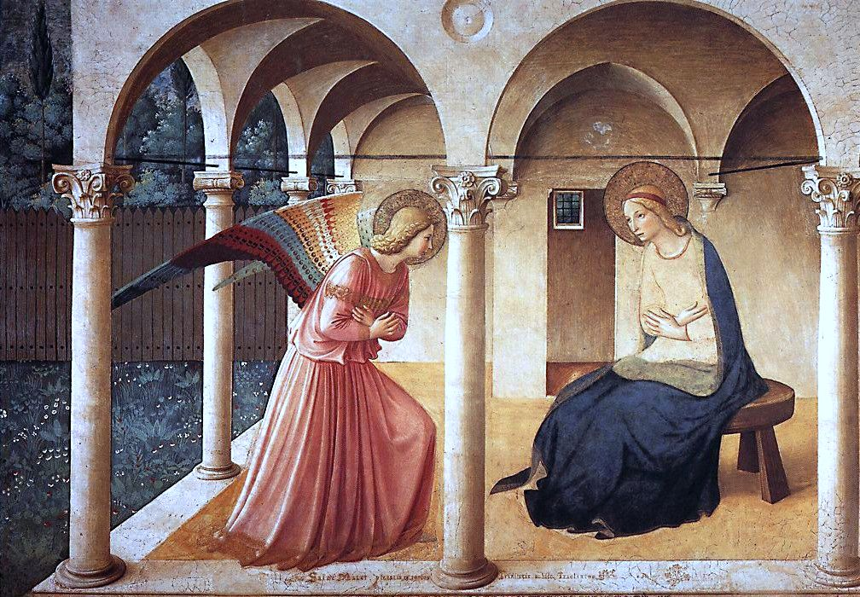
      * The Annunciation, Church of San Domenico in Fiesole, 1430-32
      * The Annunciation from the Beaufort Hours (probably owned by Lady Margaret Beaufort, Henry VIII’s mother), produced in London in mid-15th century
    - Theory – annunciation embedded in *The Miller’s Tale*
      * Shining face – similar to Christian writings
      * John – Joseph
        + Carpenter
        + Older, jealous husband
      * Nicholas – angel Gabriel
        + He plays *Angelus ad Virginum* (“The Angel to the Virgin” – a hymn about the Annunciation) on his psaltery, line 106
      * Absolon – Christ
        + Halo of golden hair
        + Longed for Alisoun like his mother (teet)
    - Older view: Underlying moral message that explains/solves everything
      * Conventional approach
    - Alt: one of the many viewpoints of the tale
* **Polyvocality** – the use of multiple voices as a narrative mode with a text, to encourage diverse readings and viewpoints

Revision, review

* Exam and Essay
  + Can’t write about the same things, but can choose same strands
* Exam preparation
  + Plan writing a commentary
    - Forms and features:
      * Place of passage in tale (where it appears and its function)
      * Historical context (cultural, social and historical features mentioned that are specific to the period, e.g., glosses of obsolete words or explanations of period-specific assumptions or practices)
      * Spelling (characteristic to ME)
      * Sounds (rhyme, homophones, puns, pronunciation – characteristic of ME or being used for a particular purpose/effect)
      * Vocabulary (French/Latin borrowings, colloquialisms, plain speaking, shifts in register – purpose/function)
      * Pragmatics (politeness strategies, choice of pronouns and address terms, relationship between the speakers)
      * Grammar (characteristic to ME)
      * Narrative viewpoint (narrator)
    - Use both linguistic and literary analysis
    - Indication of the nature of ME and Chaucer’s use of language
    - Ways to structure:
      * Topics
      * Levels of language
  + Build own storehouse of meaningful and memorable examples, e.g., *fox, gent, conclusions, Teehee!*
    - *fox*
      * ‘His berd as any sowe or fox was reed’ (The Miller’s Portrait, line 552)
    - *gent*
      * ‘As any wezele hir body gent and smal’ (The Miller’s Tale, line 126)
    - *conclusions* and *interrogations*
      * ‘And koude a certeyn of conclusions’ (line 85)
      * Polysyllabic
    - Colloquial language:
      * Onomatopoeic words (*Teehee!*)
      * Interjections that are rare in the written language (*Fy!*, *Alas!, come of, have do*)
      * Discourse markers (*lat se now, so moot I gon*)
      * Words that are rare in the written language (*gnof*, line 80)
    - Others:
      * *carl, cherl, brawn, gnof, hende, deerne, wenche, lemman, joly, ye, come of*
  + Use revision slides on each lecture (put in this lecture all together)